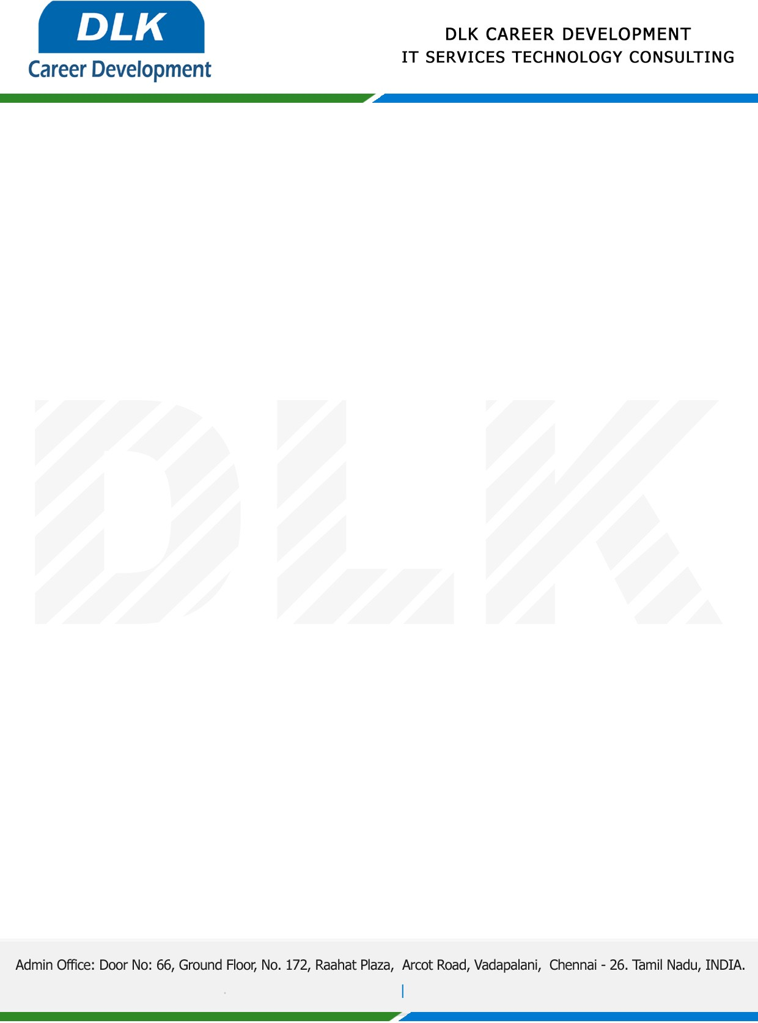

**Date: 27/April/ 2023**

**SUB: PROJECT COMPLETION CERTIFICATE**

This is to certify that **MR Surya C (REG NO:** **832100046),** final year student at **Pachaiyappas College for Men, Kanchipuram** has Successfully Completed his Project Work under the domain of “**PYTHON”** in our organization during the Period **(December 2022 to April 2023)**

**Topic**: Facial Recognition for Criminal Detection

We appreciate your interest in **DLK CAREER DEVELOPMENT**

**“Best Wishes for Your Future Endeavors “**

